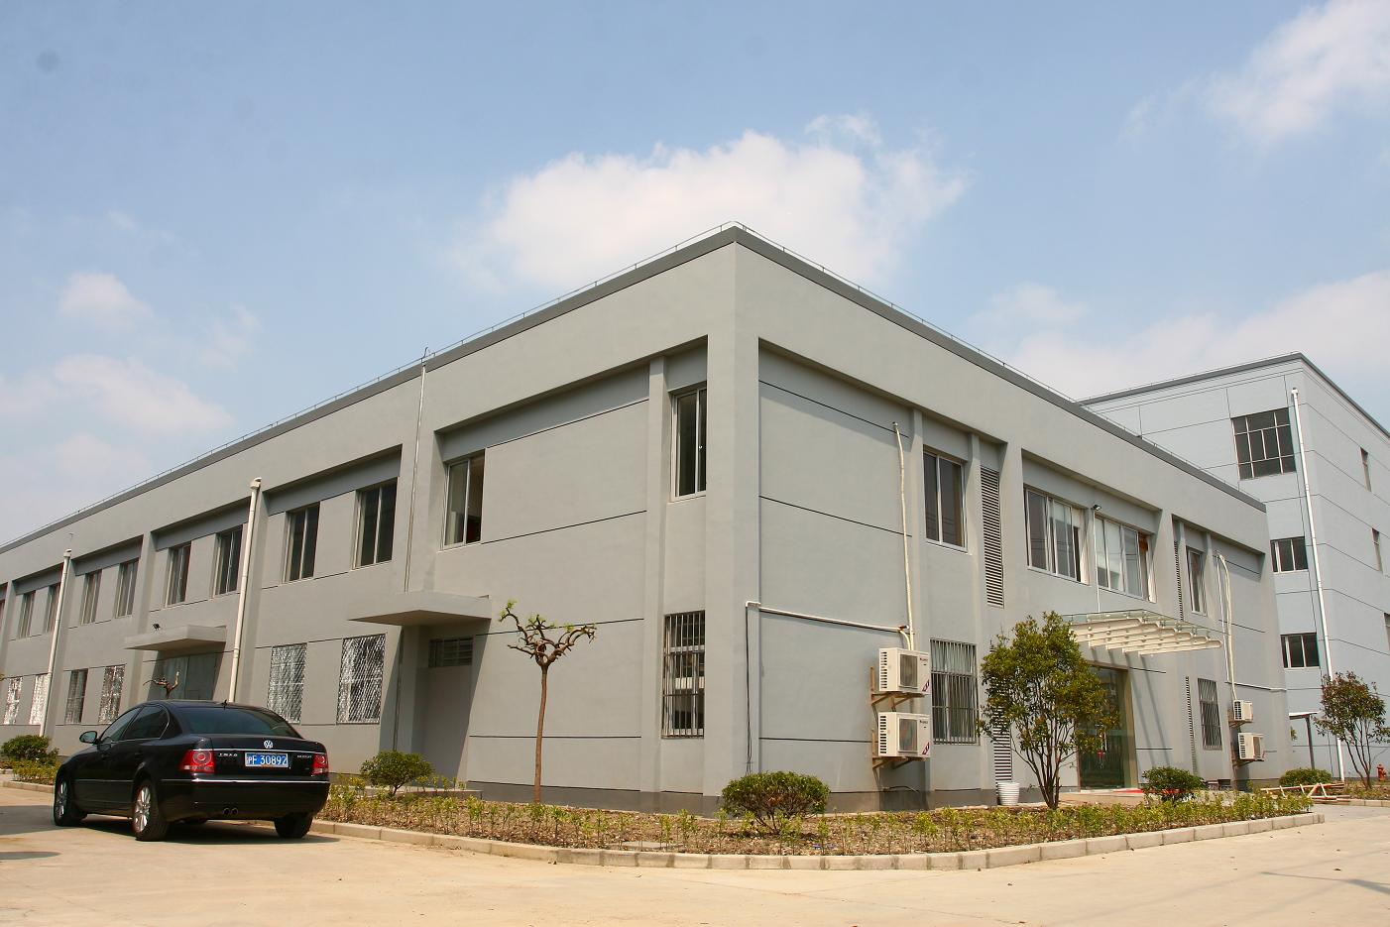**Warmly Welcome**

***( Expert in tablet press machines since 1978)***

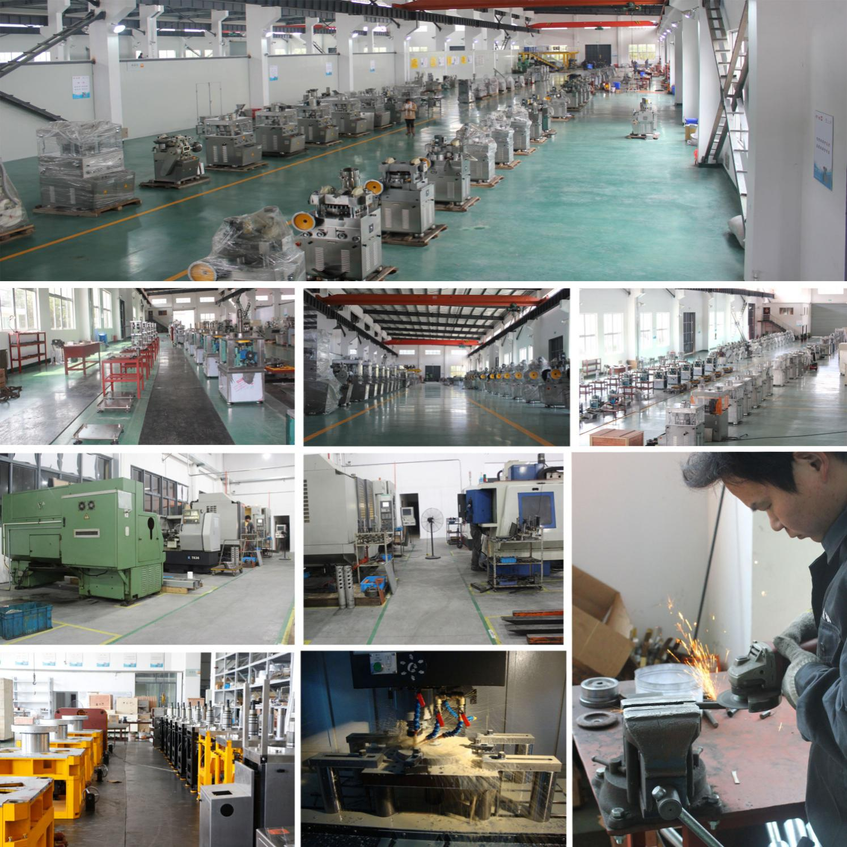Our workshops were modernized, and equipped with high precision processing facilities such as vertical and horizontal machining centers, digital CNC gantry milling machine and NC lathes, etc.

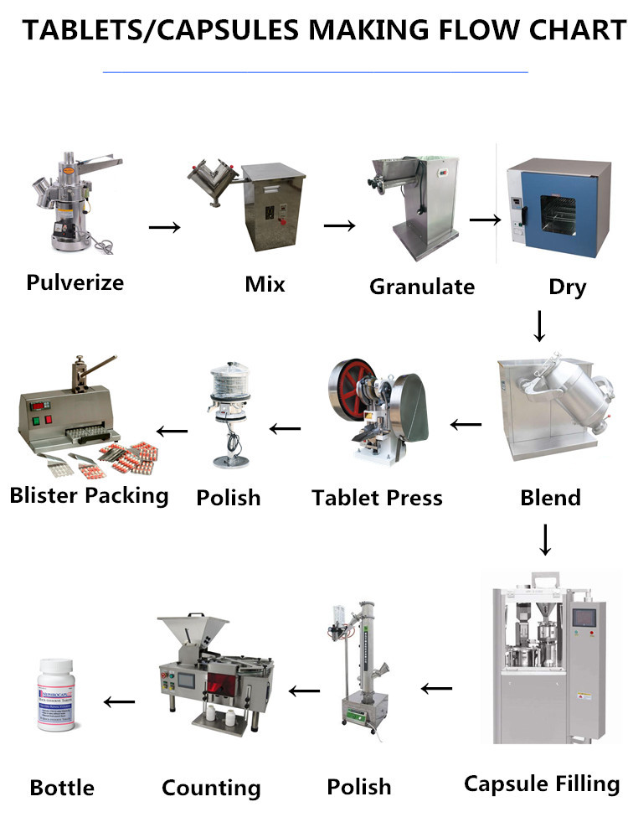

**Single Tablet Press TDP-0**

**Performance**

This machine is used for tabletting different kinds of granular raw materials into round tablet. It is applicable to trial manufacturing in Lab or batch produce in small amount different kinds of tablet, sugar piece, calcium tablet and tablet of abnormal shape. It features a small desktop type press for motive and continual sheeting. It can also be hand-operated. Only one pair of punching die can be erected on this press. Both filling depth of material and thickness of tablet are adjustable.

**Machine Photo**

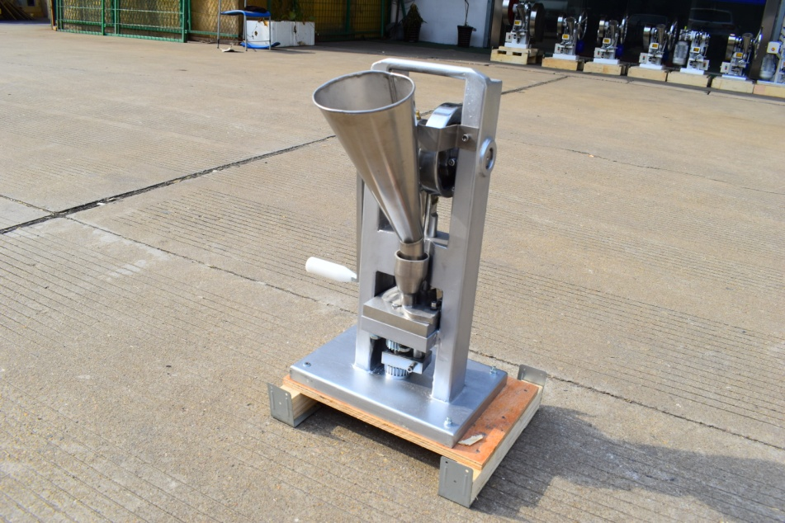

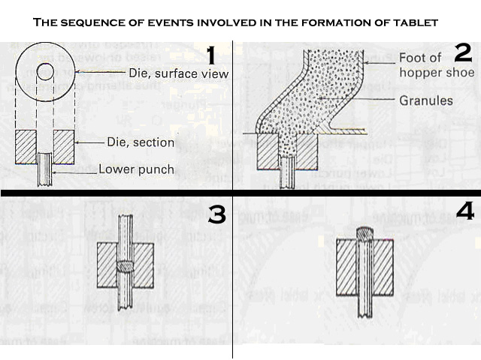

**Main Technical Data**

|  |  |
| --- | --- |
| Product No | TDP-0 |
| Max. Pressure (kn) | 15 |
| Max. Dia. of Tablet (mm) | 10 |
| Max. Depth of Filling (mm) | 15 |
| Max. Thickness of Tablet (mm) | 6 |
| Production Capacity (pcs/h) | 2000 |
| Overall Size (mm) | 400*280*560 |
| Weight (kg) | 25 |